THIRD Annual
Holland Strawberry Festival
Car – Truck – Bike Show
7807 Angola Rd, Holland, OH 43528
Saturday, June 20th, 2026, 11:00am – 2:00pm
*Bring the Family *Great Food *1 - 2 - 3 Place Trophies will be awarded to the best Car or Truck and then 1 - 2 - 3 Place Trophies to the best Motorcycle
* Entries will be judged from 12:00pm – 2:00pm.
* Questions contact: Heather VanDromme 419-215-4549
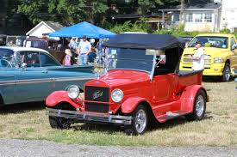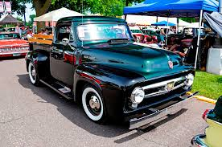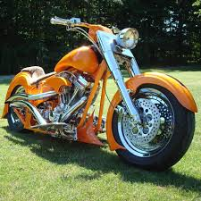
Car, Truck and Bike Show Registration Form ****** PLEASE PRINT CLEARLY******

Name (printed):_____________________________________________________________________
Address:______________________________________________________________________
City:_________________________ State:__________________________ Zip:______________
Phone:____________________________ Email:___________________________________
Vehical: Year___________ Make_____________ Model_________________
$15.00 Registration fee

